Ping Pong Ball and Hairdryer Experiment

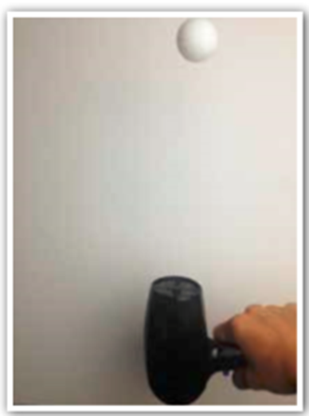

Apparatus:
o At least 1 ping pong ball (2 or 3 would be great)
o A hair dryer

Method:
o Plug in the hair dryer and turn it on.
o Put it on the highest setting and point it straight up.
o Place your ping pong ball above the hair dryer and watch what happens.
o Start to twist the hairdryer to the side slowly and smoothly.

Results:
This is a great demonstration of Newton’s laws. The air from the hairdryer pushes up, the gravity from planet Earth pulls down and the ball sits at the point where those two forces are equal! As you twist the hairdryer over to its side how come the ball doesn’t fall? That all comes down to a mathematician called Bernoulli. The air forms a stream around the ball and as you twist the hairdryer over you may well notice the ball start to spin - that’s because of its position in the airstream.

(This is the same effect that you see when football players curl free kicks, the spinning of the ball and the change of airflow caused the ball to swerve to the side).

Pepper and Water Experiment

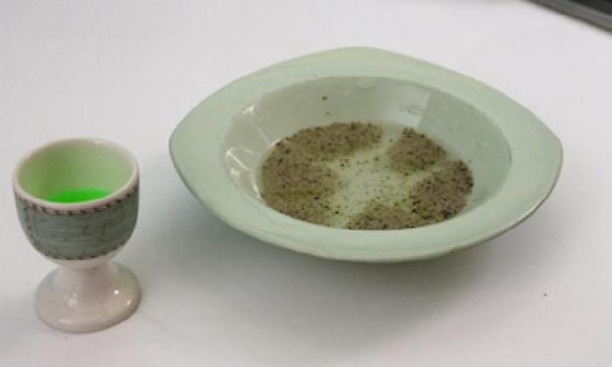

Apparatus:
- small bowl
- ground pepper
- dishwashing liquid
- cocktail stick

Method:
- Half fill a small bowl with water.
- Sprinkle pepper on the surface of the water, forming a small layer.
- With your cocktail stick, firstly dip this in the washing-up liquid.
- Then dip the tip of the stick in the middle of the water.
- As the washing-up liquid touches the water, what is happening to the pepper?
- The pepper should spread out and merge together forming patterns.

Results:
The pepper sits on the water because of the high surface tension. This means the water molecules are strongly attracted to each other. The soap breaks down the surface tension and the top layer of water molecules very quickly spread out, carrying the pepper away with them.

Mirror Drawing Challenge

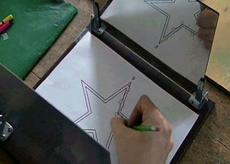

Apparatus:
  - Pencil
  - Paper
  - Mirror

Method:
- Draw a simple shape such as an apple, star or tree on some paper.
- Stand a mirror vertically against the table you are using.
- Place your paper against the glass horizontally so you can see it in the mirror.
- Now try drawing over your shape only looking in the mirror as you go.

Results:
When you look in the mirror, the top of your picture becomes the bottom and vice versa.
This makes it very difficult to copy your drawing (especially when the lines change direction).

Eggs in Vinegar

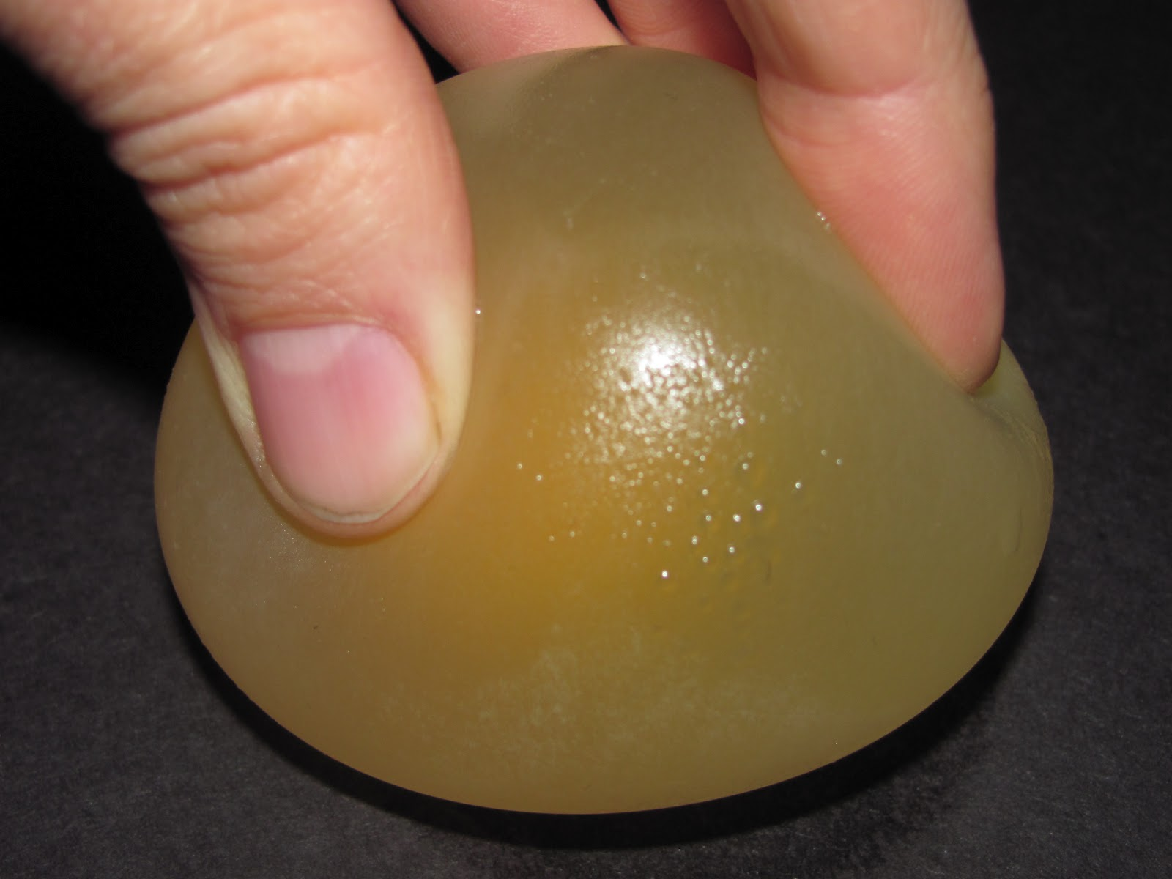

Apparatus:
- half a cup of white vinegar
- 1 x egg
- 1 x drinking glass

Method:
- Pour the vinegar into the glass
- Put the egg in the vinegar.
- Leave it for at least two days.
- After two days, take it out.
- The shell will have dissolved.
- You can carefully, gently bounce it from a low height.
- Don't try bouncing it from a great height, it's still an egg inside, not a ball!

Results:
A chemical change takes place.
The vinegar, which is an acid, reacts with the calcium carbonate of the eggshell. The change makes the shell go soft and then disappear. This is called, 'decalcification.'

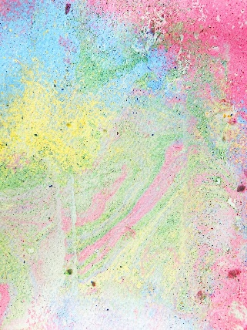
Chalk Shavings

Apparatus:
- Chalk (variety of different colours)
- Cheese grater
- Wide dish full of water
- 1 x cocktail stick
- 1 x piece of paper

Method:
- Use a cheese grater to carefully grate some different colours of chalk into a wide dish of water.
- Stir the chalk around with a cocktail stick to mix the colours a little.
- Lay some paper on the water for a few seconds then lift it off.

Results:
Chalk powder is insoluble, meaning it can’t be dissolved in water. Because of this quality, the chalk powder remains separate and stays on the surface of the water rather than mixing in. However, the chalk will stick to other surfaces, such as paper - so when paper is placed on top of the water, the chalk powder
adheres to it.

Sippy Straw Experiment

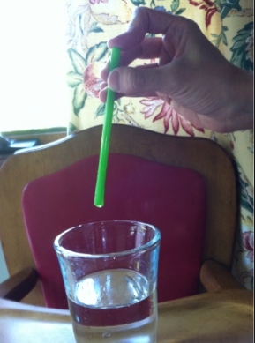

Apparatus:
- drinking straw
- two drinking glasses
- water

Method:
- Half fill one glass with water.
- Put the straw in the glass.
- Hold your finger across the top of the straw.
- Take the straw out of the water.
- Place the straw over the second empty glass and take your finger away from the top of the straw.
- The water will come out.

Results:
The atmosphere exerts a force on objects called atmospheric pressure. When the top of the straw is closed, atmospheric pressure cannot act upon the liquid from the top but it will continue to act from below. The pressure acting on the water from below, is higher than the pressure acting on the water from above. The pressure will push the water up and keep it from falling down. When the finger is lifted, the atmospheric pressure acting on both ends of the liquid in the straw becomes equal so gravity pulls the water down.

Underwater Experiment
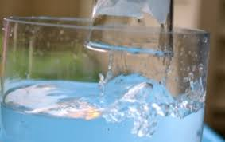

Apparatus:
- clear bowl
- water
- sheet of paper
- clear glass

Method:
- Fill the bowl with water.
- Crumple up a sheet of paper.
- Wedge the paper into the bottom of the glass. Make sure it is stuck in there.
- Tip the glass upside down and plunge it vertically into the water.

Results:
Even though the paper towel was under water, it stayed dry. This is because of the air that is also in the glass. When the glass is lowered into the water, the air is trapped inside and has nowhere to go. Therefore, the air pushes the water away as the glass is lowered. When the air pushes the water away, it keeps the water from touching the paper towel. This is why the paper towel stays dry.

Cornflour and Water Experiment
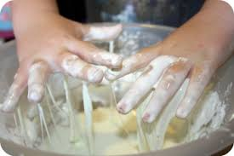

Apparatus:
- Cornflour
- Mixing bowl
- Water

Method:
- In a mixing bowl, pour in a quarter of the box of cornflour and slowly add about half a cup of water and stir.
- Continue adding cornflour and water in small amounts until you get a mixture that has the consistency of honey.
- Sink your hand into the bowl of 'quicksand' and notice its unusual consistency.
- Compare what it feels like to move your hand around slowly and then very quickly.
- Sink your entire hand into the mixture and try to grab the fluid and hold it in your hand.
- That’s the sensation of sinking in quicksand!

Results:
When we talk about states of matter, we usually talk about the three types: solid (like a rock), liquid (like water) and gas (like the air we breathe). A mixture of cornflour and water make what is known as a suspension. When you squeeze a cornflour suspension it feels like a solid because its molecules line up. However, it looks like a liquid and acts like a liquid when no one is pressing on it because the molecules relax. This is another state of matter, called a suspension (it can act like a liquid or, when pressed, it can act like a solid).

A Tissue Full of Needles

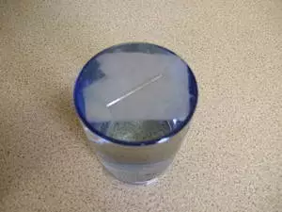

Apparatus:
- 1 x glass of water
- needle
- tissue paper

Method:
- Drop a needle into a bowl of water and watch it fall to the bottom.
- Now dry the needle.
- Place a piece of tissue paper carefully on the surface of the water and lay the needle on top.

Results:
The needle sits on the water because of the high surface tension. This means the water molecules are strongly attracted to each other where water meets air so that they form a skin-like sheet. Thin as it is, this naturally-occurring skin is strong enough to hold the needle up and prevent it from sinking. Then why did the paper sink? Well, remember that the surface tension sheet only exists at the border between air and water. The paper crossed over that border when it became soaked through with water. The needle, not being porous, remained dry.

Floating Marble

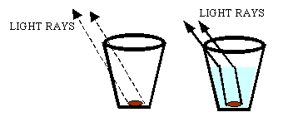

Apparatus:
- A marble
- Glass
- Water
- Blu Tack
- Plastic bowl (non-see through)

Method:
- Stick a small ball of Blu Tack to the centre of the marble.
- Stick the marble, Blu Tack side down, to the centre of the bowl's base. Make sure it is secure.
- Step far enough away from the bowl so that you can't see the marble anymore.
- Pour enough water into the bowl until the marble starts to appear.
- As you add more water, watch as the marble reveals more of itself.
- How does the marble look to be rising through the water? This is an effect of refracted light.

Results:
When the bowl is empty, the edge of the bowl stops you seeing the marble. As the water level rises in the bowl, the marble becomes visible. As light hits the water in the bowl, it changes speed and bends. This is called refraction or bending of light. Have you ever noticed that things at the bottom of a pool or river always look closer to the surface than they really are? This is because of refraction.

